存在bug
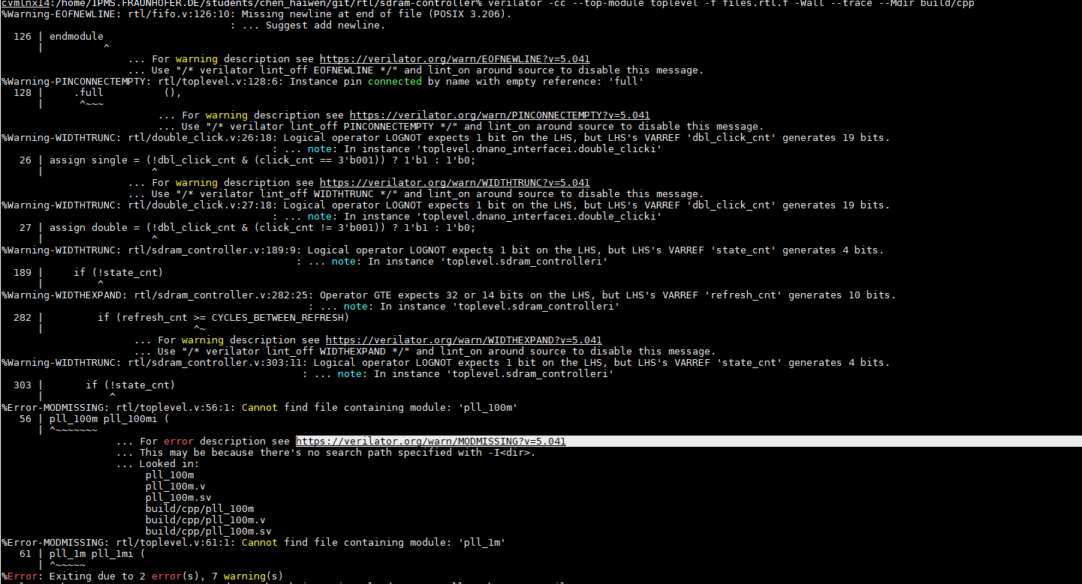
verilator --cc alu.sv
$ verilator -Wall --trace -cc alu.sv --exe tb_alu.cpp
$ make -C obj_dir -f Valu.mk Valu

If the testbench executable was built successfully, you will find a Valu binary in obj_dir.

